https://www.jacksonsart.com/paintingprize/press/

Bankside Gallery Press Release
Jackson’s Painting Prize are to showcase the 2023 competition winners and shortlisted artists at Bankside Gallery in their first independent exhibition, this July.
Jackson’s Painting Prize is an annual competition, showcasing the exceptional artwork of rising artists from around the world. The competition started in 2016 to spotlight talent in the Jackson’s Art Supplies’ community. With a focus on materials, and an impressive expert judging panel made up of exciting industry names, it’s open to artists of all ages, abilities, and stages in their careers.
Now in its eighth year, after receiving over 11,000 entries from 96 countries, Jackson’s are thrilled to exhibit a curation of the shortlisted artworks at Bankside Gallery.
NOTES TO EDITORS
Bankside Private View: 25th July, 6pm – 8pm, RSVP jpp@jacksonsart.co.uk
Open to public: 25th – 30th July, Tuesday – Sunday, 11am – 6pm daily
Admission: Free public entry, pre-booking not required
Artwork availability: Selected artworks are for sale. Please enquire at the desk, or at gallery@jacksonsart.co.uk
Social Media: #JPP2023 @jacksons_painting_prize and @jacksons_art www.jacksonsart.com/paintingprize/
About Jackson’s Art Supplies:
Founded in London in 2000, Jackson’s offers a vast range of fine art materials to artists from all over the world. At the heart of Jackson’s is a commitment to providing the finest art materials. With our expertise and knowledge, we are confident that we can supply you with the materials you need to realise your unique creative potential.
2023 WINNERS
Jackson’s Painting Prize 2023 Winner: Melissa Ling, NYC, USA
“I am thrilled to be awarded this year’s Jackson’s Painting Prize. Thank you to Jackson’s and the panel of judges for selecting my work for this honour. The prize will have a great impact towards my studio practice.”
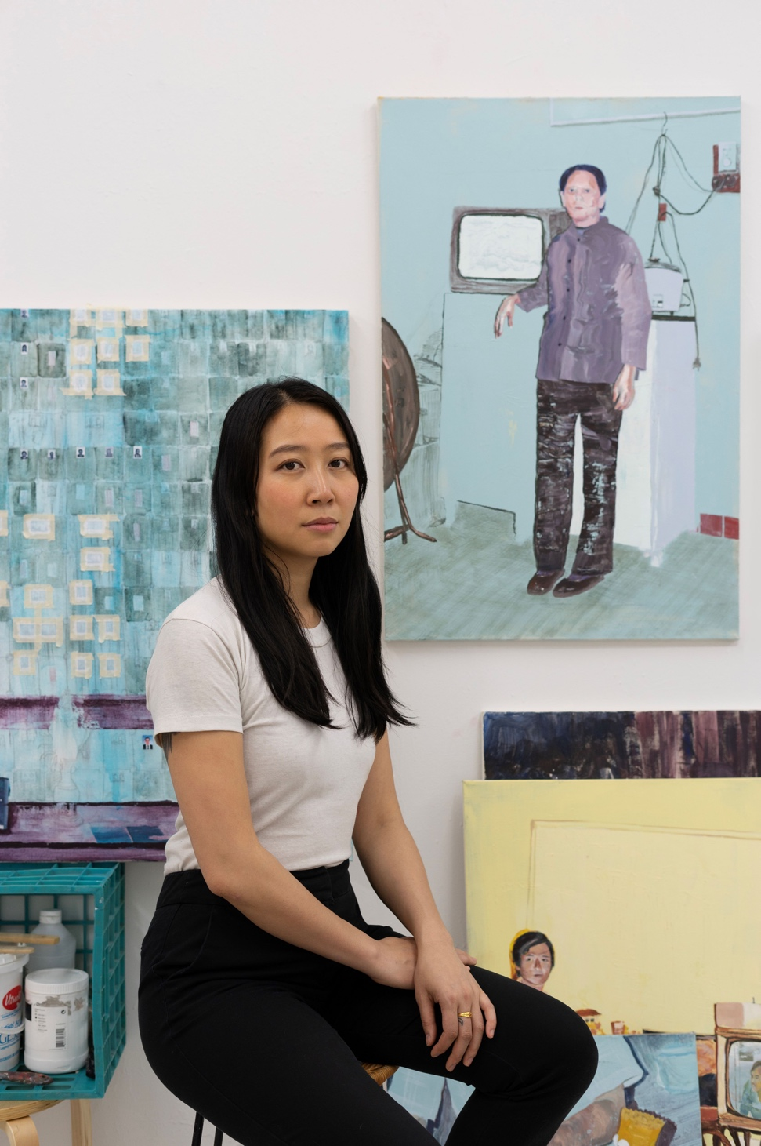

Portrait/ Figure Award Winner: Chris Longridge, UK
Landscape Award Winner: David Stewart, Canada
Animal Award Winner: Rosie Phillips, UK
Non-Representational Award Winner: Petra Schott, Germany
Still Life Award Winner: Li Ning, UK
Scenes of Everyday Life Award Winner: Robbie Bushe, UK
Mind’s Eye Award Winner: Iain Andrews, UK
Botanical Award Winner: Julia Asenbaum, Austria
Oil Award Winner: Anna Kurkova, UAE
Acrylic Award Winner: David Kinsey, USA
Dry Media Award Winner: Kylie Sandford, Canada
Watercolour Award Winner: Catherine MacDiarmid, UK
Amateur Award Winner: Kuangyi Liu, UK
Student Award Winner: Ginny Elston, UK
People’s Choice Award Winner: Lucy Gable, Portugal
BANKSIDE GALLERY
In our first ever solo exhibition at Bankside Gallery, we look forward to showcasing shortlisted artworks, including this year’s prize winners.
The artworks span a range of mediums and subject matters, and spotlight a segment of exciting rising artists from all corners of the world.
In addition to this, we look forward to hosting a range of filmed talks with the artists, judges, and guests, with a focus on materials. More information regarding the schedule will follow.
JACKSON’S ONLINE GALLERY
This year we have introduced an online platform for our shortlisted artists to have their work featured on Jackson’s Art Gallery, a space which celebrates and promotes the talented shortlisted artists from Jackson’s Painting Prize.
AFFORDABLE ART FAIR
Our opening showcase of this year’s competition took place between the 10th – 14th May, at the Affordable Art Fair on Hampstead Heath. We exhibited a small selection of shortlisters and prize winners which was a great success, including the sale of three original works.

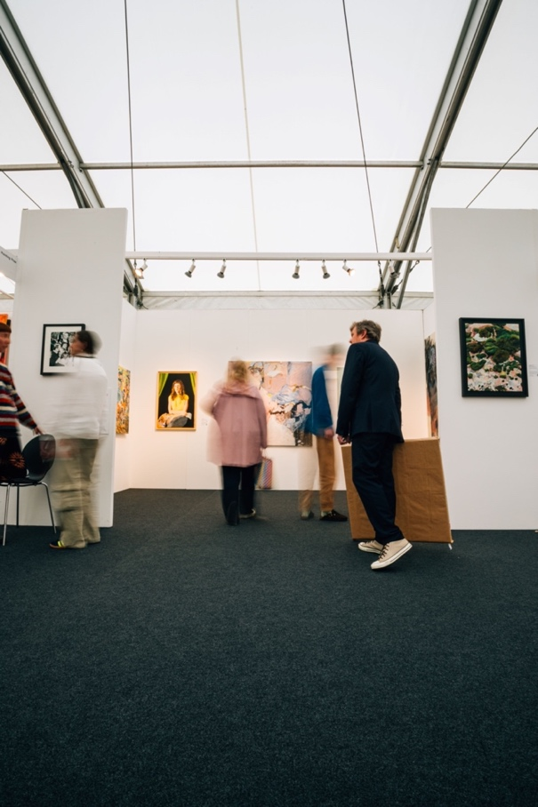

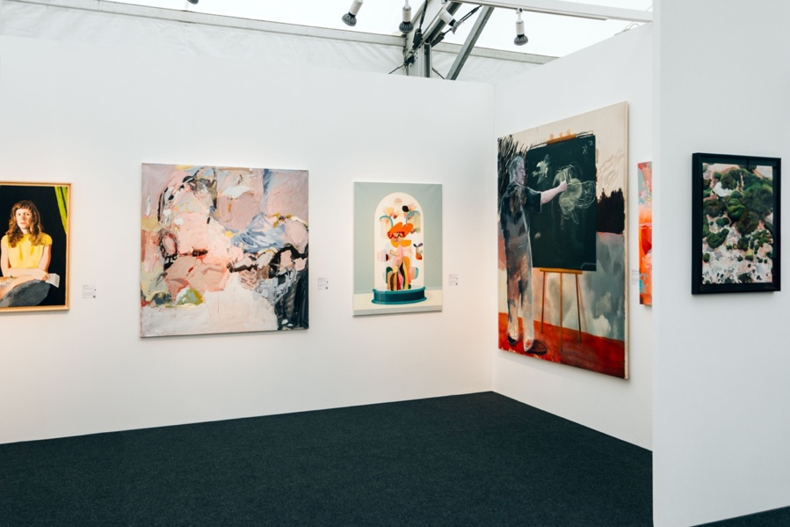

JUDGES
Kayoon Anderson: Figurative painter, Sky Portrait Artist of the Year Runner Up.
Hugo Barclay: Director of the Affordable Art Fair UK.
Martin Gayford: Art Critic, curator, and author of books including ‘In Conversation with David Hockney’ and ‘Spring Cannot be Cancelled’.
Lorena Levi: Portrait artist, Jackson’s Painting Prize 2022 Winner.
Sahara Longe: Figurative painter, represented by Timothy Taylor Gallery.
Ell Pennick: CEO and Founder of Guts Gallery
CONTACT: For further information, please contact Josephine Zentner: jpp@jacksonsart.co.uk
Jackson’s Painting Prize is proud to return to Affordable Art Fair Hampstead for the fourth time, to exhibit a selection of the shortlisted and winning artworks of 2023.
Jackson’s Painting Prize is an annual competition, showcasing the exceptional artwork of rising artists from around the world. The competition started in 2016 to spotlight talent in the Jackson’s Art Supplies’ community. With a focus on materials, and an impressive expert judging panel made up of exciting industry names, it’s open to artists of all ages, abilities, and stages in their careers.
NOTES TO EDITORS
Private View: 25th July, 6pm – 8pm, RSVP jpp@jacksonsart.co.uk
Open to public: 10th – 14th May, Tues – Fri 11am – 9pm, Sat + Sun 11am – 6pm
Admission: £10 – £27, booking required
Artwork availability: Selected artworks are for sale. Please enquire at the stand, or at gallery@jacksonsart.co.u
Social Media: #JPP2023 @jacksons_painting_prize and @jacksons_art www.jacksonsart.com/paintingprize/
About Jackson’s Art Supplies:
Founded in London in 2000, Jackson’s offers a vast range of fine art materials to artists from all over the world. At the heart of Jackson’s is a commitment to providing the finest art materials. With our expertise and knowledge, we are confident that we can supply you with the materials you need to realise your unique creative potential.
EXHIBITING WORKS:
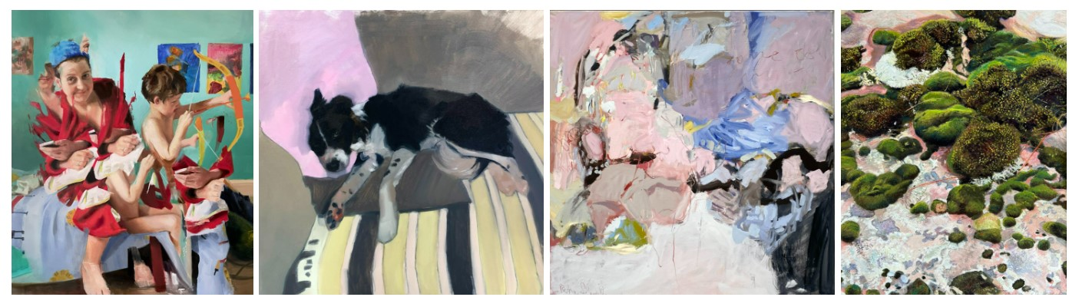
‘Venus and Cupid’, ‘Babs’, ‘And Then She Decided To Take A Bath’, ‘Microcosm I’
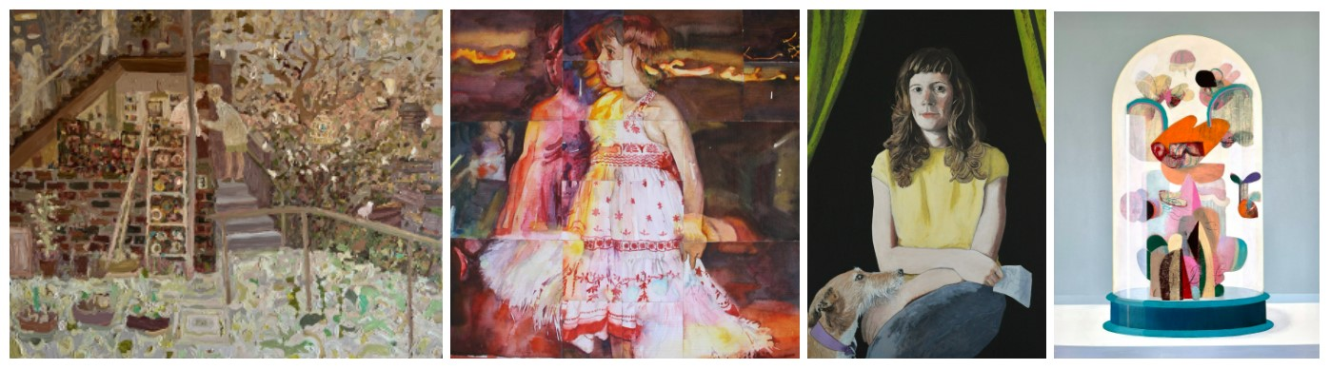
‘Night Visitor’, ‘Personal Space: Dancer’, ‘Alberta With Frida’, ‘The Sun Never Sets On Sugarcandy Mountain’
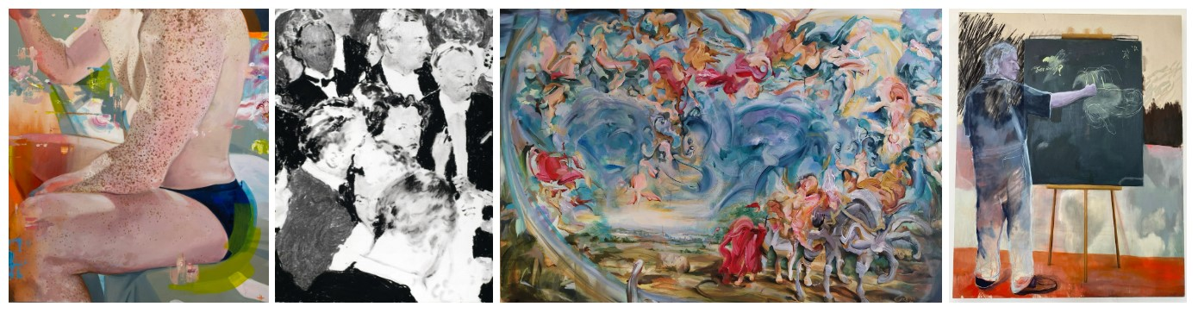
‘Sunscreen’, ‘Sherry’s’, ‘Double Portion’, ‘I Remember I Remember (The Less Deceived)’
BANKSIDE GALLERY
In addition to Affordable Art Fair, we look forward to our first ever solo exhibition at Bankside Gallery, where we will showcase shortlisted artworks including this year’s prize winners.
The artworks span a range of mediums and subject matters, and spotlight a segment of exciting rising artists from all corners of the world.
We also look forward to hosting a range of filmed talks with the artists, judges, and guests, with a focus on materials. More information regarding the schedule will follow.
JACKSON’S ONLINE GALLERY
This year we have introduced an online platform for our shortlisted artists to have their work featured on Jackson’s Art Gallery, a space which celebrates and promotes the talented shortlisted artists from Jackson’s Painting Prize.
CONTACT: For further information, please contact Josephine Zentner: jpp@jacksonsart.co.uk

